Complaints and Grievances Policy
Mandatory – Quality Area 7

Purpose
This policy will provide guidelines for:
- receiving and dealing with complaints and grievances at Box Hill North Primary School Kindergarten
- procedures to be followed in investigating complaints and grievances.
Note: This policy does not address complaints relating to staff grievances or employment matters. The relevant awards provide information on the management of such issues.

Policy statement

Values
Box Hill North Primary School Kindergarten is committed to:
- providing an environment of mutual respect and open communication, where the expression of opinions is encouraged
- ensuring all families, children and community are heard, respected and included in conversations that impact them.
- complying with all legislative and statutory requirements
- dealing with disputes, complaints and complainants with fairness and equity
- establishing mechanisms to promote prompt, efficient and satisfactory resolution of complaints and grievances
- maintaining confidentiality at all times.

Scope
This policy applies to the Approved Provider, Nominated Supervisor, Certified Supervisor, educators, staff, students on placement, volunteers, parents/guardians, children and others attending the programs and activities of Box Hill North Primary School Kindergarten.

Background and legislation

Background
Box Hill North Primary Kindergarten will ensure all complaints and grievances are addressed,
investigated fairly and documented in a timely manner. Complaints or grievances
may be received from anyone who comes in contact with Box Hill North Primary Kindergarten
including Parents/Guardians, volunteers, students, members of the local community
and other agencies.
In most cases, dealing with complaints and grievances will be the responsibility of the Approved Provider. All complaints and grievances, when lodged, need to be initially assessed to determine whether they are a general or a notifiable complaint (refer to Definitions).
When a complaint or grievance has been assessed as 'notifiable', the Approved Provider must notify Department of Education and Early Childhood Development (DET) of the complaint or grievance. The Approved Provider will investigate the complaint or grievance and take any actions deemed necessary, in addition to responding to requests from and assisting with any investigation by DET.
There may be occasions when the complainant reports the complaint or grievance directly to DET. If DET then notifies the Approved Provider about a complaint they have received, the Approved Provider will still have responsibility for investigating and dealing with the complaint or grievance as outlined in this policy, in addition to co-operating with any investigation by DET.
DET will investigate all complaints and grievances it receives about a service, where it is alleged that the health, safety or wellbeing of any child within the service may have been compromised, or that there may have been a contravention of the Education and Care Services National Law Act 2010 and the Education and Care Services National Regulations 2011.
Contact details of who to contact with a complaint or grievance are located at the entrance of the kindergarten, next to the door into the classroom.

Legislation and standards
Relevant legislation and standards include but are not limited to:
- Charter of Human Rights and Responsibilities Act 2006 (Vic)
- Children, Youth and Families Act 2005 (Vic)
- Education and Care Services National Law Act 2010: Section 174(2)(b)
- Education and Care Services National Regulations 2011: Regulations 168(2)(o) and 176(2)(b)
- Information Privacy Act 2000 (Vic)
- National Quality Standard, Quality Area 7: Leadership and Service Management
  - Standard 7.3: Administrative systems enable the effective management of a quality service
    - Element 7.3.4: Processes are in place to ensure that all grievances and complaints are addressed, investigated fairly and documented in a timely manner
- Privacy Act 1988 (Cth)
- Privacy Regulations 2013(Cth)
The most current amendments to listed legislation can be found at:
- Victorian Legislation – Victorian Law Today: http://www.legislation.vic.gov.au/
- Commonwealth Legislation – ComLaw: http://www.comlaw.gov.au/

Definitions
The terms defined in this section relate specifically to this policy. For commonly used terms e.g. Approved Provider, Nominated Supervisor, Regulatory Authority etc. refer to the General Definitions section of this manual.
Complaint: (In relation to this policy) a complaint is defined as an issue of a minor nature that can be resolved promptly or within 24 hours, and does not require a detailed investigation. Complaints include an expression of displeasure, such as poor service, and any verbal or written complaint directly related to the service (including general and notifiable complaints).
Complaints do not include staff, industrial or employment matters, occupational health and safety matters (unless related to the safety of the children) and issues related to the legal business entity, such as the incorporated association or co-operative.
Complaints and Grievances Register: (In relation to this policy) records information about complaints and grievances received at the service, together with a record of the outcomes. This register must be kept in a secure file, accessible only to educators and Responsible Persons at the service. The register can provide valuable information to the Approved Provider on meeting the needs of children and families at the service.
Dispute resolution procedure: The method used to resolve complaints, disputes or matters of concern through an agreed resolution process.
General complaint: A general complaint may address any aspect of the service e.g. a lost clothing item or the service's fees. Services do not have to inform DET, but the complaint must be dealt with as soon as is practicable to avoid escalation of the issue.
Grievance: A grievance is a formal statement of complaint that cannot be addressed immediately and involves matters of a more serious nature e.g. the service is in breach of a policy or the service did not meet the care expectations of a family.
Mediator: A person (neutral party) who attempts to reconcile differences between disputants.
Mediation: An attempt to bring about a peaceful settlement or compromise between disputants through the objective intervention of a neutral party.

Notifiable complaint: A complaint that alleges a breach of the Act or Regulation, or alleges that the health, safety or wellbeing of a child at the service may have been compromised. Any complaint of this nature must be reported by the Approved Provider to the secretary of DET within 24 hours of the complaint being made (Section 174(2)(b), Regulation 176(2)(b)). If the Approved Provider is unsure whether the matter is a notifiable complaint, it is good practice to contact DET for confirmation. Written reports to DET must include:
- details of the event or incident
- the name of the person who initially made the complaint
- if appropriate, the name of the child concerned and the condition of the child, including a medical or incident report (where relevant)
- contact details of a nominated member of the Grievances Subcommittee/investigator
- any other relevant information.
Written notification of complaints must be submitted using the appropriate forms, which can be found on the ACECQA website: www.acecqa.gov.au
Serious incident: A serious incident is defined in Regulation 12 as:
• the death of a child while being educated and cared for by the service
• any incident involving an injury or trauma, or the illness of a child that requires or ought to have required:
– attention of a registered medical practitioner, or
– attendance at a hospital
examples include whooping cough, broken limb, anaphylaxis reaction
• any incident requiring attendance by emergency services
• a circumstance where a child appears to be missing, is unaccounted for, has been removed from the service contrary to the Regulations, or has been locked in or out of the service premises.
The Approved Provider must notify the Regulatory Authority (DET) in writing within 24 hours of a serious incident occurring at the service (Regulation 176(2)(a)). The Notification of serious incident form (available on the ACECQA website) is to be completed and submitted online using the National Quality Agenda IT System (NQA ITS). Records are required to be retained for the periods specified in Regulation 183.

Sources and related policies

Sources
- ACECQA: www.acecqa.gov.au
- Department of Education and Early Childhood Development (DET) – Regional Office details are available under ‘Contact Us’ on the DET website: www.education.vic.gov.au
- ELAA Early Childhood Management Manual: www.elaa.org.au
- The Kindergarten Guide (Department of Education and Early Childhood Development) is available under early childhood / service providers on the DET website: www.education.vic.gov.au

Service policies
- Code of Conduct Policy
- Incident, Injury, Trauma and Illness Policy
- Inclusion and Equity Policy
- Interactions with Children Policy
- Privacy and Confidentiality Policy
- Staffing Policy

Procedures

The Approved Provider is responsible for:
- being familiar with the Education and Care Services National Law Act 2010 and the Education and Care Services National Regulations 2011, service policies and constitution, and complaints and grievances policy and procedures
- identifying, preventing and addressing potential concerns before they become formal complaints/grievances
- ensuring that the name and telephone number of the Responsible Person (refer to Staffing Policy) to whom complaints and grievances may be addressed are displayed prominently at the main entrance of the service (Regulation173(2)b))
- ensuring that the address and telephone number of the Authorised Officer at the DET regional office are displayed prominently at the main entrance of the service (Regulation 173(2)(e))
- advising parents/guardians and any other new members of Box Hill North Primary School Kindergarten of the complaints and grievances policy and procedures upon enrolment
- ensuring that this policy is available for inspection at the service at all times (Regulation 171)
- being aware of, and committed to, the principles of communicating and sharing information with service employees, members and volunteers
- responding to all complaints and grievances in the most appropriate manner and at the earliest opportunity
- treating all complainants fairly and equitably
- providing a Complaints and Grievances Register (refer to Definitions) and ensuring that staff record complaints and grievances along with outcomes
- complying with the service's Privacy and Confidentiality Policy and maintaining confidentiality at all times (Regulations 181, 183)
- establishing a Grievances Subcommittee or appointing an investigator to investigate and resolve grievances (refer to Attachment 1 – Sample terms of reference for a Grievances Subcommittee/investigator)
- referring notifiable complaints (refer to Definitions), grievances (refer to Definitions) or complaints that are unable to be resolved appropriately and in a timely manner to the Grievances Subcommittee/investigator
- informing DET in writing within 24 hours of receiving a notifiable complaint (refer to Definitions) (Act 174(4), Regulation 176(2)(b))
- receiving recommendations from the Grievances Subcommittee/investigator and taking appropriate action.

The Nominated Supervisor, Certified Supervisors, educators and other staff are responsible for:
- responding to and resolving issues as they arise where practicable
- maintaining professionalism and integrity at all times
- discussing minor complaints directly with the party involved as a first step towards resolution (the parties are encouraged to discuss the matter professionally and openly work together to achieve a desired outcome)
- informing complainants of the service's Complaints and Grievances Policy
- recording all complaints and grievances in the Complaints and Grievances Register (refer to Definitions)
- notifying the Approved Provider if the complaint escalates and becomes a grievance (refer to Definitions), is a notifiable complaint (refer to Definitions) or is unable to be resolved appropriately in a timely manner
- providing information as requested by the Approved Provider e.g. written reports relating to the grievance
- complying with the service's Privacy and Confidentiality Policy and maintaining confidentiality at all times (Regulations 181, 183)
- working co-operatively with the Approved Provider and DET in any investigations related to grievances about Box Hill North Primary School Kindergarten, it's programs or staff.

Parents/guardians are responsible for:
- raising a complaint directly with the person involved, in an attempt to resolve the matter without recourse to the complaints and grievances procedures
- communicating (preferably in writing) any concerns relating to the management or operation of the service as soon as is practicable
- raising any unresolved issues or serious concerns directly with the Approved Provider, via the Nominated Supervisor/educator or through the Grievances Subcommittee/investigator
- maintaining complete confidentiality at all times
- co-operating with requests to meet with the Grievances Subcommittee and/or provide relevant information when requested in relation to complaints and grievances.

Volunteers and students, while at the service, are responsible for following this policy and its procedures.

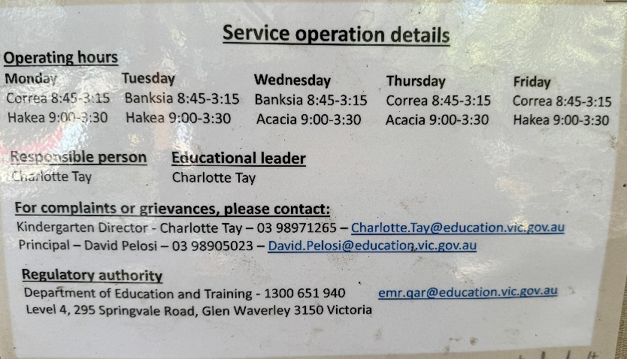
To lodge a complaint of grievance, please see below for the details:

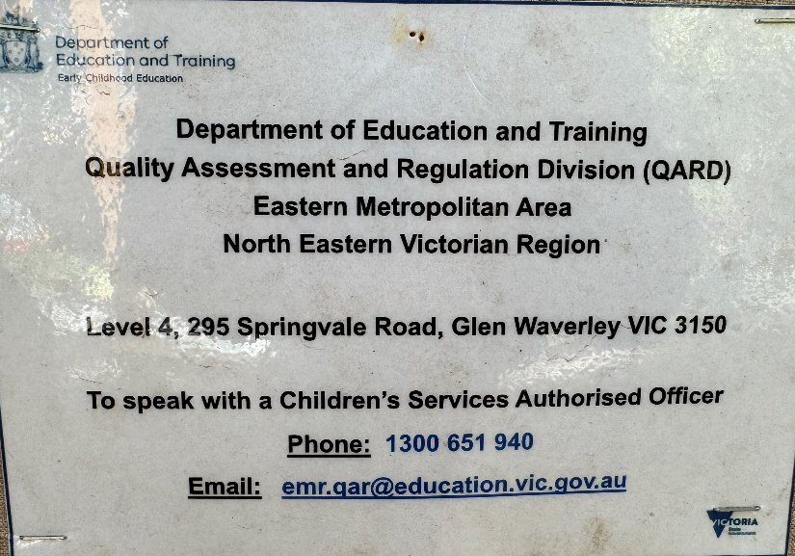

Evaluation
In order to assess whether the values and purposes of the policy have been achieved, the Approved Provider will:
- regularly seek feedback from everyone affected by the policy regarding its effectiveness
- monitor complaints and grievances as recorded in the Complaints and Grievances Register to assess whether satisfactory resolutions have been achieved
- review the effectiveness of the policy and procedures to ensure that all complaints have been dealt with in a fair and timely manner
- keep the policy up to date with current legislation, research, policy and best practice
- revise the policy and procedures as part of the service's policy review cycle, or as required
- notify parents/guardians at least 14 days before making any changes to this policy or its procedures.

Attachments
- Attachment 1: Sample terms of reference for a Grievances Subcommittee/investigator
- Attachment 2: Dealing with complaints and grievances

Authorisation
This policy was adopted by the Approved Provider of Box Hill North Primary School Kindergarten on 15/5/17.
This policy was review on the 7th of March, 2024.

Review date: mARCH 2026

Attachment 1
Sample terms of reference for a Grievances Subcommittee/investigator
DATE ESTABLISHED:

Purpose

- A Grievances Subcommittee has been established by the Approved Provider of Box Hill North Primary School Kindergarten to investigate and resolve grievances lodged with Box Hill North Primary School Kindergarten.
- An investigator/panel of investigators has been appointed by the Approved Provider of Box Hill North Primary School Kindergarten to investigate and resolve grievances lodged with Box Hill North Primary School Kindergarten.

Membership

Three people are nominated by the Approved Provider, and membership must include a minimum of one Responsible Person (refer to Definitions).

Time period nominated
The Grievances Subcommittee/investigator shall be appointed for .

Meeting requirements
The subcommittee convenor/investigator is responsible for organising meetings as soon as is practicable after receiving a complaint or grievance.

Decision-making authority
The subcommittee/investigator is required to fulfil only those tasks and functions as outlined in these terms of reference.
The Approved Provider may decide to alter the decision-making authority of the subcommittee/investigator at any time.

Budget allocation
All expenditure to be incurred by the subcommittee/investigator must be approved by the Approved Provider. A request in writing must be submitted by the subcommittee/investigator.

Reporting requirements of the committee
- The subcommittee/investigator is required to keep minutes of all meetings held. These are to be kept in a secure file.
- The convenor is required to present a written report to the Approved Provider about the grievance, ensuring that privacy and confidentiality are maintained according to the service's Privacy and Confidentiality Policy.

Tasks and functions of the Grievances Subcommittee/investigator
- Responding to complaints in a timely manner
- Investigating all complaints received in a discreet and responsible manner
- Implementing the procedures outlined in Attachment 2 – Dealing with complaints and grievances
- Acting fairly and equitably, and maintaining confidentiality at all times
- Informing the Approved Provider if a complaint is assessed as notifiable

- Keeping the Approved Provider informed about complaints that have been received and the outcomes of investigations
- Providing the Approved Provider with recommendations for action
- Ensuring decisions are based on the evidence that has been gathered
- Reviewing the terms of reference of the Grievances Subcommittee/investigator at commencement and on completion of their term. Suggestions for alterations are to be presented to and approved by the Approved Provider
Attachment 2
Dealing with complaints and grievances

Dealing with a complaint
When a complaint is received, the person to whom the complaint is addressed will:
- inform the complainant of the service's Complaints and Grievances Policy
- encourage the complainant to resolve the complaint with the person directly, or to submit their complaint in writing
- enter the complaint in the Complaints and Grievances Register (refer to Definitions) together with the outcome
- comply with the service's Privacy and Confidentiality Policy with regard to all meetings/discussions in relation to a complaint
- inform the Approved Provider if the complaint escalates and becomes a grievance (refer to Definitions), a notifiable complaint (refer to Definitions) or is unable to be resolved appropriately in a timely manner.

Dealing with a grievance
When a formal complaint or grievance is lodged with the service:
- the staff member receiving the formal complaint or grievance will record all relevant details regarding the grievance in the Complaints and Grievances Register (refer to Definitions) and immediately inform the Approved Provider
- the Approved Provider must inform the service's Grievances Subcommittee, if there is one, or appoint an investigator(s) to investigate the grievance
- the Grievances Subcommittee/investigator will assess the grievance to determine if it is a notifiable grievance (refer to Definitions)
- if the grievance is notifiable, the Approved Provider will be responsible for notifying DET. This must be in writing within 24 hours of receiving the complaint (Regulation 176(2)(b))
- the written report to DET needs to be submitted using the appropriate forms from ACECQA and will include:
  - details of the event or incident
  - the name of the person who initially made the complaint
  - if appropriate, the name of the child concerned and the condition of the child, including a medical or incident report (where relevant)
  - contact details of a nominated member of the Grievances Subcommittee/investigator
  - any other relevant information
- if the Approved Provider is unsure if the complaint is a notifiable complaint, it is good practice to contact DET for confirmation.

Grievances Subcommittee/investigator responsibilities and procedures
In the event of a grievance being lodged, the Grievances Subcommittee/investigator will:
- convene as soon as possible to deal with the grievance in a timely manner
- disclose any conflict of interest relating to any member of the subcommittee/panel of investigators. Such members must stand aside from the investigation and subsequent processes
- consider the nature and the details of the grievance
- identify which service policies (if any) the grievance involves
- inform the Approved Provider if their involvement is required under any other service policies
- if the grievance is a notifiable complaint (refer to Definitions), inform the complainant of the requirements to notify DET of the grievance and explain the role that DET may take in investigating the complaint
- maintain appropriate records of the information and data collected, including minutes of meetings, incident reports and copies of relevant documentation relating to the grievance
- respect the confidential nature of information relating to the grievance. The Approved Provider and the subcommittee/investigator must handle any grievance in a discreet and professional manner
- store all written information relating to grievances securely and in compliance with the service's Privacy and Confidentiality Policy.

Investigating the grievance and gathering relevant information
When investigating the grievance and gathering relevant information, the Grievances Subcommittee/investigator will:
- meet with individual witnesses, and give right of reply to the person against whom the allegations are made in relation to any accusation or information relating to an alleged incident
- offer the complainant the opportunity of meeting with the subcommittee/investigator to discuss the complaint and provide additional information where relevant
- nominate a subcommittee member to inform the complainant of the procedures for dealing with the grievance if the complainant does not take up the opportunity to attend a meeting
- document the time, date and detail of meetings/discussions, and follow this up with a letter to the complainant outlining the information discussed
- be available to meet with DET staff, if required, and provide additional information as requested
- review relevant information and documents
- obtain any other relevant information or documentation that will assist in resolving the grievance
- seek advice, where appropriate, from individuals and organisations that may be able to assist in resolving the grievance (any cost in seeking advice will require prior approval by the Approved Provider).

Following the investigation
Once the investigation of the grievance is complete, the Grievances Subcommittee/investigator will:
- endeavour to resolve the grievance by mutual agreement of the parties involved
- meet to discuss the information gathered and determine further action, including generating recommendations to be presented to the Approved Provider
- ensure that any recommendations or actions are in accordance with relevant legislation and funding requirements including, but not limited to:
  - Education and Care Services National Law Act 2010
  - Education and Care Services National Regulations 2011
- The Kindergarten Guide (refer to Sources)report outcomes that may include relevant information gained in investigations and consultations to the Approved Provider and, where required, provide any recommendations for consideration by the Approved Provider
- inform the Approved Provider on the involvement of DET and the outcomes of any investigation by DET. The Approved Provider will review the report and any subcommittee/investigator recommendations and will be responsible for making decisions on the action to be taken (if any), including relevant review mechanisms
- advise the complainant and other relevant parties of any decisions made by the Approved Provider in relation to the grievance
- follow up to ensure the parties involved are satisfied with the outcome and monitor progress on any actions taken by the Approved Provider.

